Name ___________________

ID Number ___________________
Psychology 200 – Data and Statistics
Take Home Exam 3

Directions: Record your answers on this exam. Staple your work to the exam and make sure your name is on everything. All work should be stapled to the exam in the order that the questions were asked. You must show your work for ALL hand calculations to receive full credit (you may use a calculator for basic math functions but calculate statistics without SPSS). Round FINAL ANSWERS to the nearest 100th. Please follow ALL directions.

Computation (10 points):

In a one-sample t-test, what is the estimated standard error for a sample (s = 21) of 53 students? __2.88_________ (2 points)
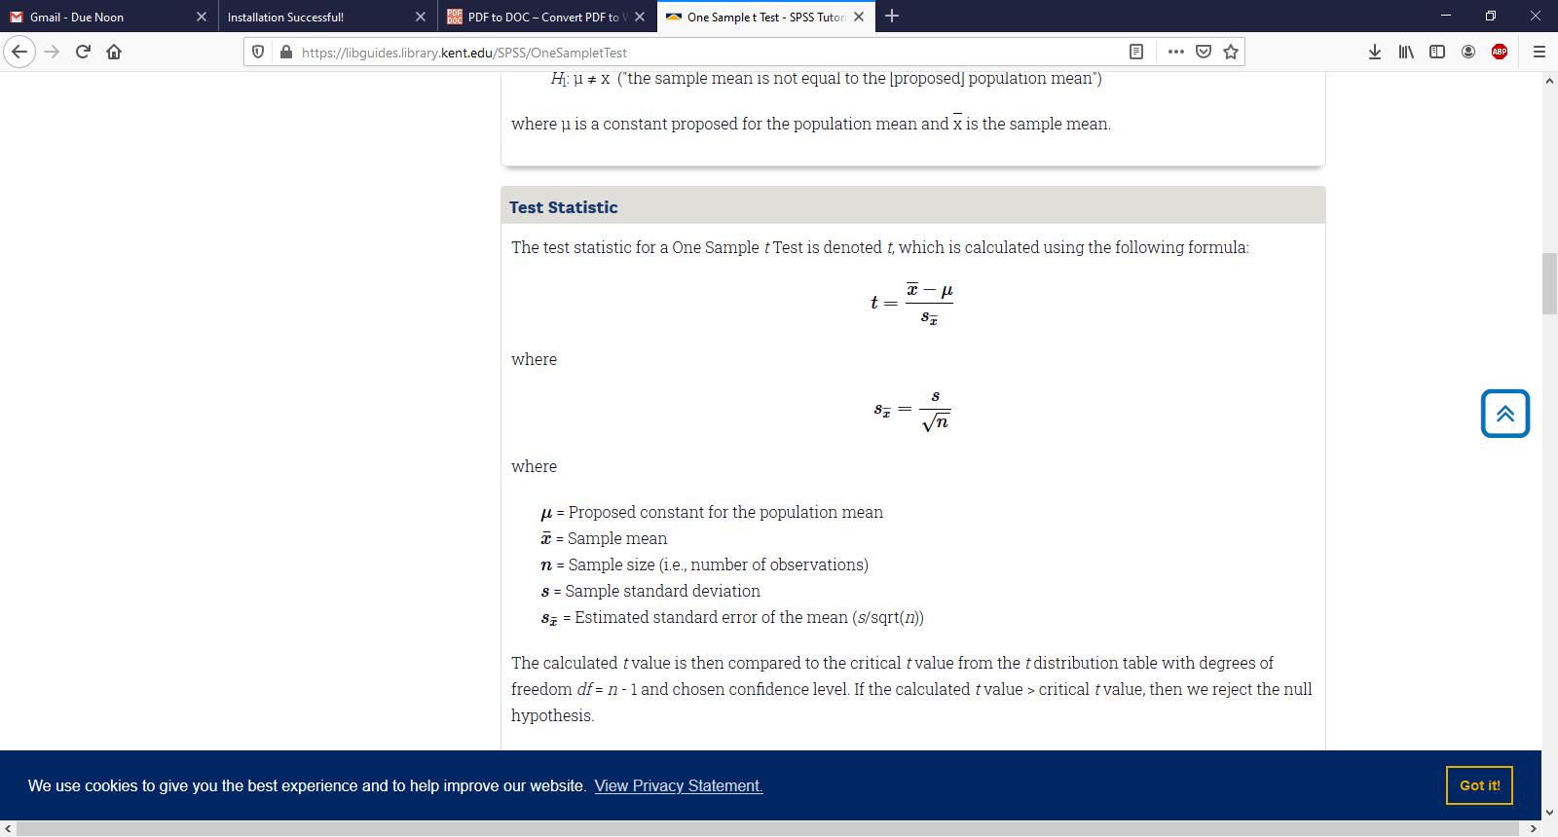
In an independent samples t-test, what is the value of FMAX when s1 = 23 and s2 = 29?
___1.59_________ (2 points)
F max=29^2/23^2
F Max=1.59

In an independent-samples t-test, with two groups of equal size (n), Group 1 has a mean of 112 and a standard deviation of 19 and Group 2 has a mean of 119 and a standard deviation of 27. Calculate estimated Cohen’s d. ___-0.30_______ (2 points)
d=(112-119)/23.3452
d=-0.30

In a related-samples (paired-samples) t-test, one set of scores has a mean of 2,366, and the other set of scores has a mean of 2,045. What is the mean of the difference scores?

_________321 _ (2 points)
D=x-y
2366-2045=321

Jerri collects data from 100 people about how much mileage they put on their vehicle each week. She’s interested in how age affects driving habits, so he divides the sample into two groups: people under 40 and people 40 or over. What type of t-test should Jerri use to make this comparison? _________independent sample t test__________________________________ (2 points)

Study 1 (20 points): You are a researcher hired by Western Colorado University to investigate depression in psychology majors there. You ask a random group of 15 undergraduates majoring in psychology (ages 18 – 30) to fill out a survey regarding their support for the Health Care Reform act. Higher scores (on a scale from 1-10) indicate higher depression. Listed below is each person’s score on your survey. The national average in depression for this age range as measured by this scale is µ = 5. Calculate by hand (show your work) the appropriate t-test to determine whether the average depression in your sample is different from the national average. Name and follow the steps of hypothesis testing below.

ID | Survey Score
1 | 7
2 | 1
3 | 3
4 | 2
5 | 7
6 | 5
7 | 6
8 | 3
9 | 5
10 | 5
11 | 5
12 | 2
13 | 5
14 | 6
15 | 4

Test statistic (1 point):
t=
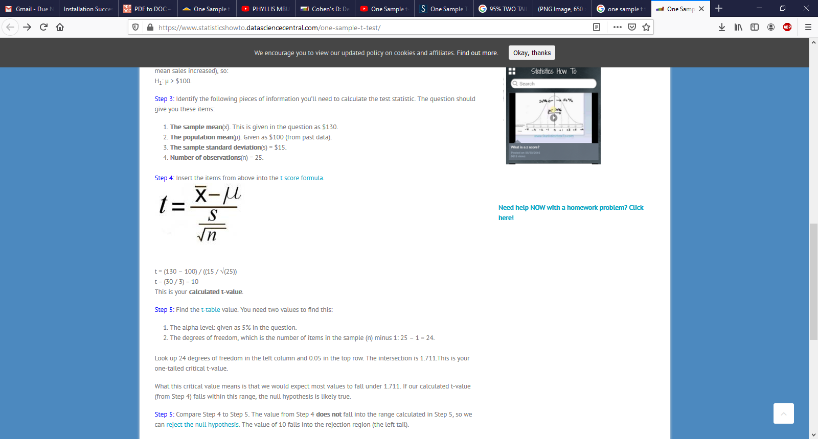

t= (4.4-5)/(1.8439/√15)

t= -1.26
Step 1 (2 points):
Stating the hypothesis

H0: µ = 5

H1: µ ≠5

Step 2 (2 points):
Stating alpha

Alpha

σ=0.05

Step 3 (4 points):
Degrees of freedom

DF=15-1

DF=14

Step 4 (5 points):

Stating the decision rule at 95% confidence interval

If t is less than -2.14474 or greater than 2.14474 reject the null hypothesis

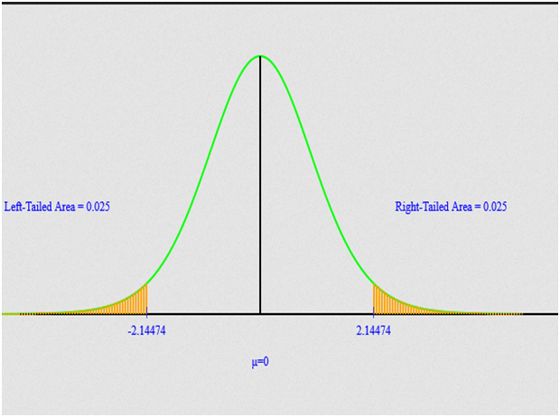

Step 5 (4 points):
Results

The calculated test statistic is -1.26 and is greater than the critical value -2.14474 hence we fail to reject the null hypothesis

Step 6 (2 points):

Conclusion
The average depression in your sample is NOT different from the national average

Study 2 (20 points): You have recruited 43 people and randomly assigned them to either of 2 groups. Each person in the first group (n = 21) receives alcohol until their blood-alcohol content (BAC) is measured at .08. People in the second group (n = 22) receive water, and their BAC is measured to ensure that it is .00 before testing. Then, members of both groups are asked to complete the same word search containing 50 words. You are interested in whether the number of words found significantly differs between the two groups.

ID | Group | Words Found | ID | Group | Words Found
1 | 1 | 25 | 22 | 2 | 34
2 | 1 | 28 | 23 | 2 | 36
3 | 1 | 26 | 24 | 2 | 28
4 | 1 | 13 | 25 | 2 | 32
5 | 1 | 37 | 26 | 2 | 38
6 | 1 | 14 | 27 | 2 | 40
7 | 1 | 19 | 28 | 2 | 45
8 | 1 | 28 | 29 | 2 | 47
9 | 1 | 23 | 30 | 2 | 42
10 | 1 | 23 | 31 | 2 | 43
11 | 1 | 40 | 32 | 2 | 49
12 | 1 | 17 | 33 | 2 | 41
13 | 1 | 12 | 34 | 2 | 41
14 | 1 | 15 | 35 | 2 | 40
15 | 1 | 29 | 36 | 2 | 45
16 | 1 | 27 | 37 | 2 | 46
17 | 1 | 22 | 38 | 2 | 18
18 | 1 | 32 | 39 | 2 | 17
19 | 1 | 14 | 40 | 2 | 39
20 | 1 | 19 | 41 | 2 | 41
21 | 1 | 25 | 42 | 2 | 46
 |  |  | 43 | 2 | 27

Without using SPSS, name AND conduct the appropriate hypothesis test to determine whether the two groups significantly differ in number of words found. Be sure to name AND follow each of the six steps of hypothesis testing.

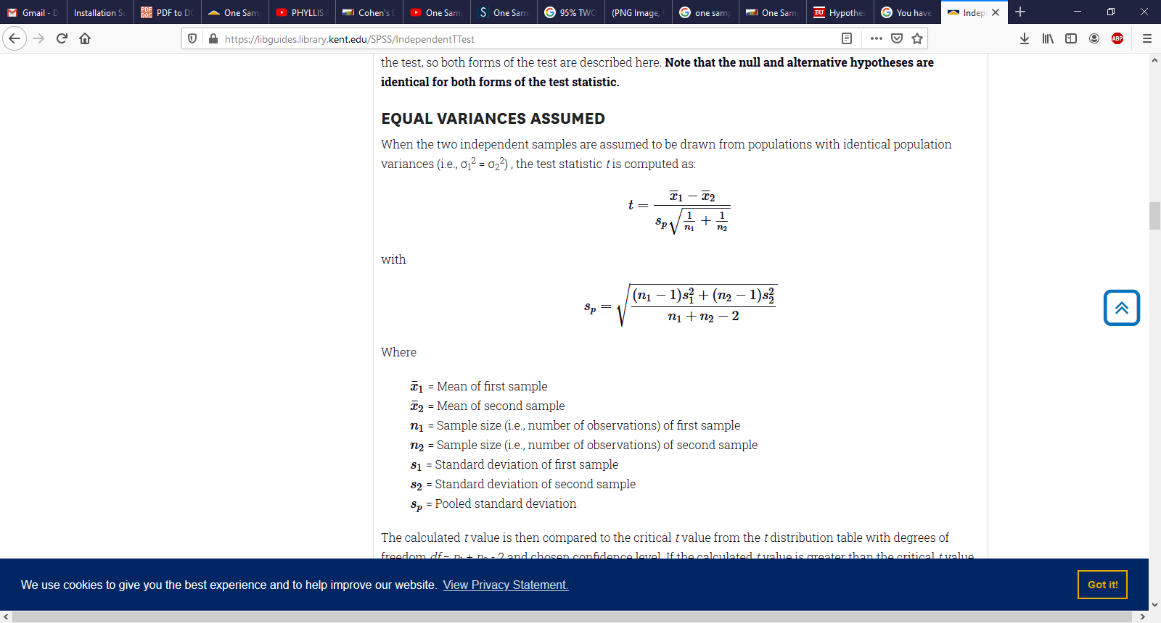

Sp=8.212
T=(23.24-38.48)/(8.21*0.31)
T=-15.24/25.34
T=-0.60

Step 1 (2 points):
Stating the hypothesis

H0: µ1 = µ2

H1: µ1≠ µ2

Step 2 (2 points):
Stating alpha

Alpha

σ=0.05

Step 3 (4 points):
Degrees of freedom

DF=N1+N2-2

DF=40

Step 4 (5 points):

Stating the decision rule at 95% confidence interval

If t is less than -2.02104 or greater than 2.02104 reject the null hypothesis

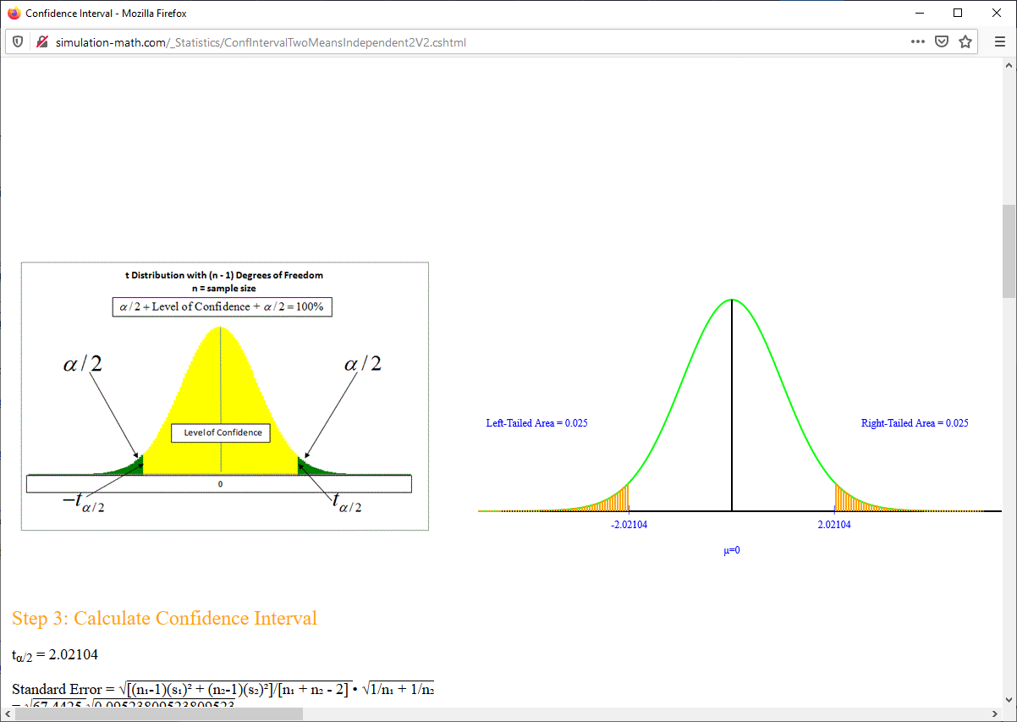

Step 5 (4 points):
Results

The calculated test statistic is -0.60 and is greater than the critical value -2.02104 hence we fail to reject the null hypothesis

Step 6 (2 points):

Conclusion

The number of words found significantly does NOT differ between the two groups

For extra credit (2 points) calculate the opposite effect size statistic from the ones you did above (if you haven’t already), 1 point for each study

cohens d=(M1-M2)/SD pooled
cohens d =(23.24-38.48)/(8.21)
cohens d =(23.24-38.48)/(8.21)
cohens d =-1.86

